There are many types of risks to which an industry or the company has been exposed to round the year. Some examples of types of risks are the financial risks, economic risks, political risks, etc. However, under current circumstances, the present economic credit and economic crisis have significant impact over the businesses around the world. In general, economic risks are divided under three heads which includes idiosyncratic, systematic, and systemic varieties. Idiosyncratic risks are the risks which is specific to some specific category of assets in a small group which has been employed in a business. This type of risks has very little or almost nil correlation with that of the market risk. Hence, it can be easily diluted by diversifying the portfolio of the company’s risks assets. Also, it is responsible for most of the changes in the inventories and the stocks of the business rather than the market risk over the period of time.
Another type of economic risks to which any business would be exposed to is the systematic risk also called as the aggregate risk or the risk which cannot be removed by diversifying the portfolio of the company’s assets. It has direct impact over the aggregate macroeconomic variables and the broad market returns which affects the total economy wide resources or we can say the aggregate income of the economy. On the other hand, we have the systemic risk in which there is risk of collapse of the entire market or the entire financial system rather than just one individual identity or the company involved. (Marlor, 1997)
We have chosen Nike Shoe Company for our analysis of risks involved in the shoe business in the U.S. The financial health for the shoes company would depend on the number of factors such as number of people who have joined gym in nearby area, number of people who go for morning walk, percentage of young generation in the country, percentage of male population in the country, etc. we have to take an idea about all such factors which would directly impact the business growth in next few years. The idiosyncratic risk involved in the Nike shoe company is the frequent changes in the prices of the company’s stocks which has little relation with the managerial expertise of the company. The reason being the changes in the country’s financial position that is the fluctuations in the interest rate, changes in the tax policy, little control over the rate of inflation, etc. These are the factors which affect the stock prices of the company. The idiosyncratic risks involved will be the ability of the company to price its products profitably, effect on the strength of the company’s supply chain and the prowess of the company’s marketing strategy.
Asset allocation in Nike has been influenced by the systematic risk because it is a global company which has diversified its assets as the multinational company in many countries. The factors which impact the company under systematic risk are the lower returns such as over the U.S Treasury securities invested by the company. We have the third type of economic risk which is the systemic risk in the company which includes Systemic risk because it called as the risk which is “too big to fail.” Since Nike has expanded its business globally therefore if there is any problem in any corner of the world, it would highly impact the business of the company in most of its branches due to capitalization of the risks involved in the company. Most of the global companies are interconnected and any change in the working of the company in a country highly impacts the working of the same company in the other region as well. However, the company has the option to keep its systemic risk minimum by owning stocks in different companies and in different industries. There are several macroeconomic variables that are associated empirically with an increase in the identified varieties of risk, and which may indicate an increase or decrease in systematic and systemic risk specifically. Inflation rate and the interest rate in the economy will increase the systematic risk involved in the investing into the business. Also, changes in the money supply and variability in the aggregate industrial production would further increase the systematic risk involved in the company. On the other hand, systemic risk is affected by the country’s aggregate savings and the investment because higher the investment of the country more will be the expansion of the company globally due to higher FDI involved. Also Nike has very unsystematic involvement of the borrowers and the credit factors affecting the credibility of the debtors of the company. It also increases the idiosyncratic risks of the company as the company might have bad debts in future due to this reason.
Expected Fixed cost
- Rent $100,000
- Machinery $400,000
- Installation charges $100,000
- Advertising $100,000
TOTAL - $700,000

Expected variable cost
- Material $500,000
- Labour wage $100 per pair
- Electricity bill $100,000 per month
TOTAL - $600,000 + $100* number of pair
Hence, Expected Annual Sales and Profit for the next 3 Years:
- Year 2015: Sales- $500 000
Expenses - $450 000
Profits- $50 000
- Year 2016: Sales- $700 000
Expenses- $350 000
Profits- $350 000
- Year 2017: Sales- $900 000
Expenses- $400 000
Profits- $500 000

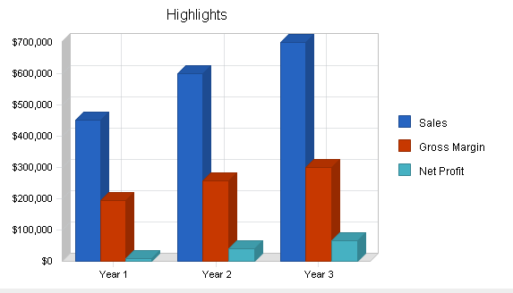

Therefore, our shoe co. would like to finance its growth in near future through borrowings which would have an impact on the debt to equity ratio and thereby we would be able to generate cash flow in our business. The investment level would depend on the interest rate in the market as we know that we will borrow less in case of higher interest rate. It would ultimately reduce the investment in our business. Because of the cost of inventory and warehousing and marketing costs of establishing a market presence, our business will be financed primarily a financial loan in the early stages and is expected to burn cash.
We will analyse the time period when we will be able to break even, that is where total revenue would be equal to total cost. We will expect that investment will be highest in the first quarter as after that in the mid of 2015 we will be able to break even. (King, 2010)
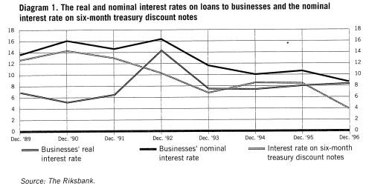
The above diagram shows how the fluctuations in the macroeconomic variables are directly related to the changes in the economic risks involved in the Nike business.
Hence, it can be concluded that the risks involved in the business are trade-off with that of the profit rate in the economy.

Works Cited
Karen A. Langone, D. (2010). How to Evaluate and recommend athletic shoes. AMERICAN ACADEMY OF PODIATRIC SPORTS MEDICINE.
King, A. D. (2010). Sustainability Assessment of Nike Shoes. For Sustainability Science ENVS 195, Fall.
Marlor, F. (1997). Macroeconomic indicators of systemic risks. Soverigen Riksbank, 10-14.
Mary E. Harris, S. V. (2012). Introduction to Athletic Shoes. THE UNIVERSITY OF AKRON.

